Synoptix Report Guide

Table of Contents 1
Things to Know Before Requesting a Report 2
Requesting a Report 2
Accessing a Report 3
Running a Report 5
FAQ 8
Appendix 1: Pre-Built Reports 9
Appendix 2: Advanced Topics 11

Things to Know Before Requesting a Report

Synoptix has unique benefits and limitations the user needs to be aware of before requesting any report.

- Synoptix is not real time. The Synoptix database is updated overnight and ready at 6 am the following day. Synoptix will contain all prior day posted activity.

- No individual student or employee account information is available for reporting. This information cannot be downloaded from Colleague to ensure privacy. Therefore, no individual payroll, vendor, or student account reports are available.

- Synoptix is enabled with single sign-on and access is limited to the OTC network. This means if you are logged in at OTC or via the OTC Virtual Private Network (VPN) then your reports are accessible. Do not leave your computer unattended and logged in. If you do, your reports can be accessed.

- Each July, you may begin to receive two reports until August: one for the current fiscal year and one for prior year. Keep in mind it usually takes a couple of weeks before the current year activity begins to post. Prior year reports will run until July 31 unless otherwise requested.

- For grants’ reporting, Synoptix defaults to a June 30th end date. We have ways to utilize Synoptix and Excel to create more usable reports for those that do not have a June 30th end date. Please contact the finance office if you are requesting grant information that does not have a June 30th end date.

Requesting a Report

  - After reading the above section, complete the Request for Synoptix Report form which can be found on R:\Finance Office Forms\Synoptix, the Finance website or use the following link. Synoptix-Request-Form.xlsx.

  - Email the completed form to Financereport@otc.edu

  - A member of the finance team will contact you acknowledging your request and make arrangements for setting up, testing, and scheduling your reports.

Accessing a Report

- Your reports will be emailed to you at the scheduled time from synoptix@otc.edu

- For reviewing your information, attached reports in PDF and optional Excel formats make it quick and easy to see your requested data. If you need further details, click the link in the email for the interactive HTML report.
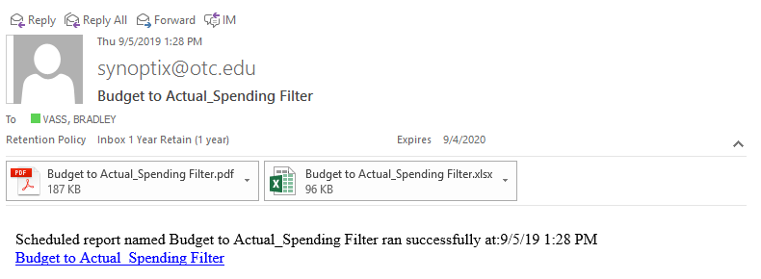

- To view your interactive HTML Report, click the link at the bottom of the email.

- The Interactive report allows you to select any item and see the transaction detail. This is also known as drilling down. To drill down, left click on the amount, and then left click on the account. You should now be able to see every transaction that makes an account balance. Be sure to bookmark the site so you can refer back as a quick reference without going to your email.
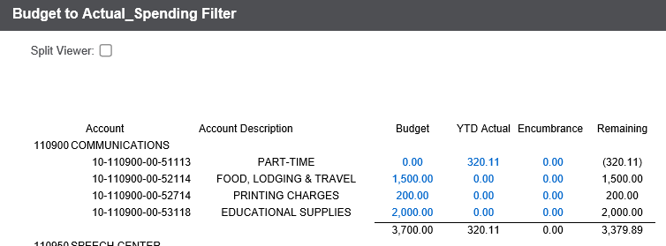

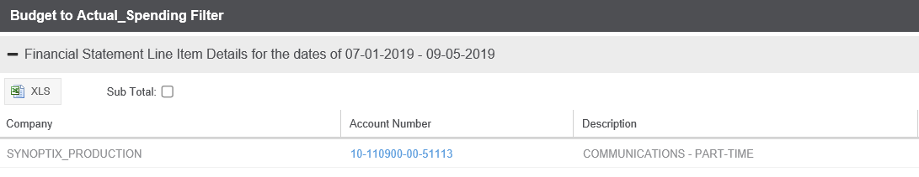

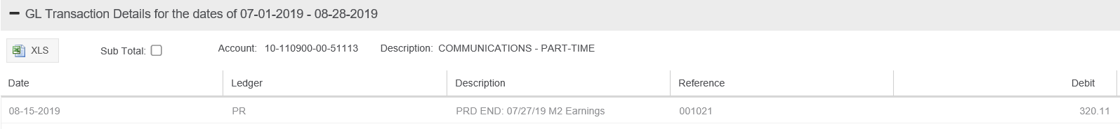

Running a report
Caution: Running a new HTML report will override your existing HTML report. The link in your e-mails will only go to the latest version of the report ran. Refer to your PDF or Excel document in your original email if you wish to see data from the older report.

- From any HTML report you have open, left click the Ellucian link in the upper right corner. It should take you to the Synoptix Report Generator.
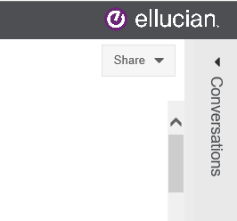

- Left click on the drop down menu to the left of the Ellucian logo. Select the Reports option.

- Left click on the report you want to run. Then left click on the “Run Now” option. 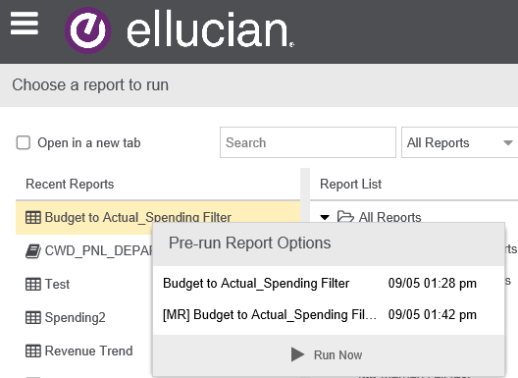

- Enter the start and/or end date of the information you want to update and left click Run.
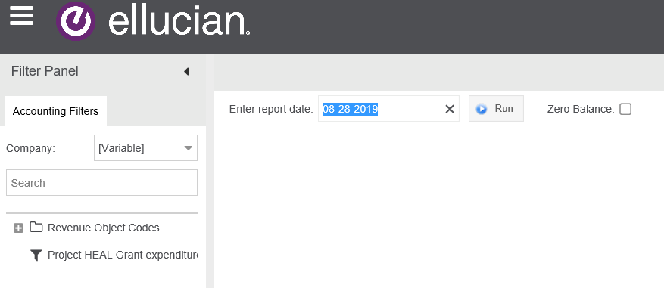

- Your updated report should be ready to review.

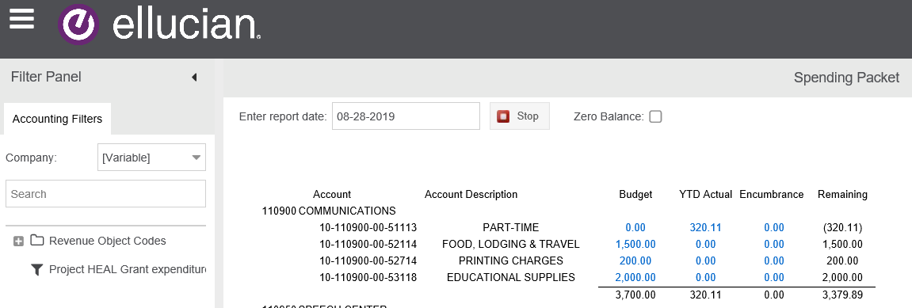

- In the upper right hand corner, you should be able to export an Excel document by left clicking the Share button and selecting the file type you want.

FAQ
Why does my report not match information in Colleague?

Remember, data is not real time. The best time to compare the two reports is first thing in the morning before 9 am, and they should match. However if you still feel your report is not running correctly, do not hesitate to contact Finance and someone will check your report.

How frequently can I get my reports?

You can get them as often as hourly and as seldom as annually. In addition, you can run your reports manually if you need an update other than the scheduled day of the report. See section 4 of this guide, Running a Report, for more details.

How do I change or update my reports?

Please contact a member of Finance to adjust an existing report.

What is different about Colleague and Synoptix? Why do I not just get my reports from Colleague?

Synoptix allows the Finance department to customize and memorize reports for your continued use. It also improves communication to be able to send your reports on a regular schedule.

Is Colleague going away?

No, Colleague is still a very valuable tool and will be available during the foreseeable future.

I want several reports but I want them in one e-mail. Can you do this?

Yes, Finance can deliver several reports in a single packet, which is very similar to an Excel Workbook. Please consult Appendix 2 and contact the finance department to set up your packet.

When is the best time to receive reports?

Each report is unique and you should discuss with Finance when setting up your report. However, test groups have frequently requested 8 am on Wednesdays because the weekly check run is included and updated Tuesday night.

Can I see the expense details from my attached PDF or Excel Document?

Yes, but you will need to contact finance to change your report. You can only drill down expenses using the HTML document.

Appendix 1 Pre-Built Reports

- Budget to Actual

The spending report is a summary list of all your spending accounts. Spending reports do not include full time payroll or benefits accounts. It only includes Part Time (51113), Contract Employees (51223), and all other expenses (52000 thru 59999). In other words it only includes the accounts a department can spend. An example is below. This report is very similar to your GLBR and GLBA reports in Colleague for a select group of accounts.

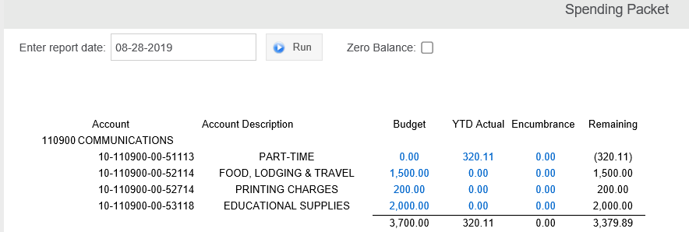

- Actual Activity Detail with Budget

This report gives you the transaction details and budget of your selected accounts. This is similar to your LGLA reports in Colleague.

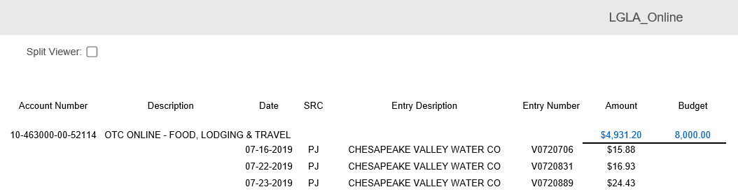

- Actual Activity Summary

This is a listing of all actual activity in each line item for a range of accounts. This is very similar to a GLTB Summary Report in Colleague.
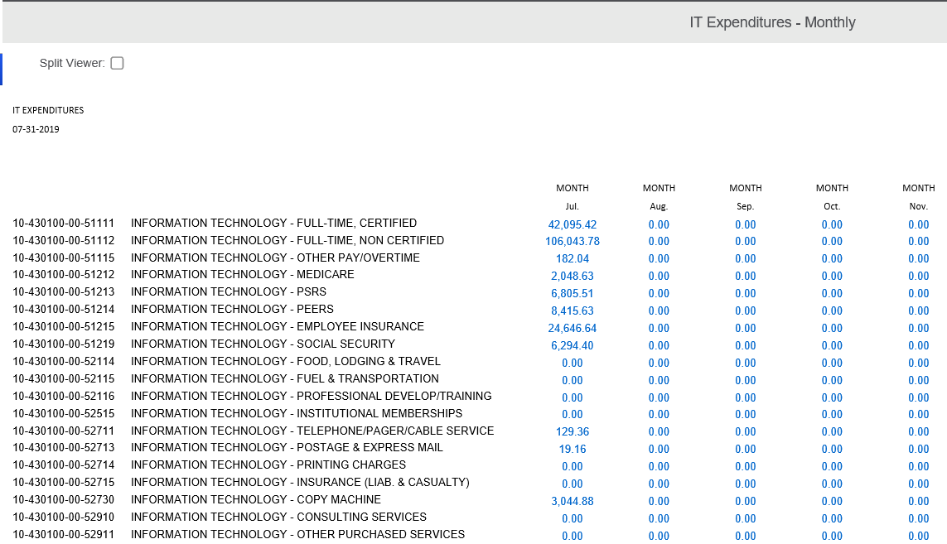
Appendix 2 Advanced Topics

- Packets
Packets are a grouping of worksheets that look very similar to an Excel workbook. Packets allow you to view and organize information for multiple departments, locations and/or divisions. Below is a screen shot of a packet for all the departments of Continuing Workforce Development.

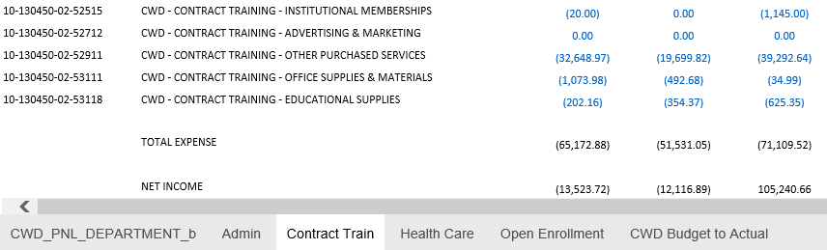

- Custom Report Design
One of the great features of Synoptix is the ability to customize the way you want to see your data. In addition, you can view it without adding special fields in Colleague. Co-workers are currently using custom reports for the following information.

    - Multiple locations
    - Divisions (Technical Education, General Education, Academic Support, etc.)
    - Monthly Budgets

If standard reports are not working you may inquire about developing custom reports. Depending on the complexity, custom reports may take up to 60 business days to complete.

